CTM-I Use Case

TCP/IP Re-Send

Version 0.1

Use Case Name | TCP/IP Re-Send
Actor | Operations, App Support
Pre-conditions /Assumptions | User has Browser and is aware of the http path to the application.  User has successfully logged into the CTM-I application.  User has the right role to see the menu options.
Post Conditions | None
Screenshot | 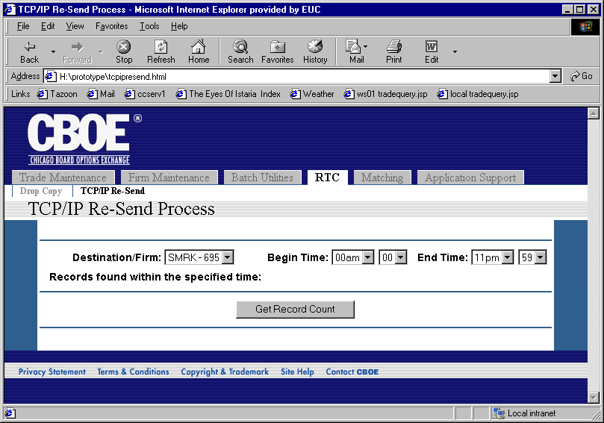
Flow of Events | - User selects “TCP/IP Re-Send” from the menu  - A request is sent to CTM-R to get the list of Destination IDs and Firms.  - The TCP/IP Re-Send screen is displayed.  - Destination/Firm fields shows the valid combinations of Destination ID and Firm that can receive a Re-Send. The user selects the appropriate selection from the list.  - The user selects a Begin Time and End Time for the records to re-send.  - The user presses the “Get Record Count” button to process the criteria and get a count of records that match.  - The request is sent to CTM-R to get the count of records  - The screen is refreshed and the count displayed to the user.  - The user presses the “Re-Send Records” button to process the re-send.  - The criteria is sent to CTM-R to process the re-send.  - The results of the processing by CTM-R are displayed on the refreshed screen.
Alternative Path | 1. If the user changes any of the criteria after getting a record count, the user is forced to get another record count. The user cannot perform a re-send without first getting a count for the criteria specified.

